My son Maximilian is 5 months old and has been a nutrition and chiropractic patient of Dr. Jen’s from his first days of life. Max has struggled with severe eczema for most of his short little life. Many people think of eczema as a few patches of dry skin here and there. For most people, that is true. But for Max it means head to toe red, dry, scaly, cracked and oozing skin. There have been times where he didn’t have a clear patch of skin on his whole body. The bacteria on his skin that is benign for most people caused him constant inflammation and infection. He even had to be on antibiotics and steroids for awhile because the infection and inflammation got so bad. Because of his constant discomfort, he was always a terrible sleeper, oftentimes waking up every hour all night for nights on end. The constant bacterial infection led to 2 ear infections, one after the other. Needless to say, his first months of life have been incredibly challenging for Max and for his parents! Watching him cry and itch his skin until it bled was heartbreaking.
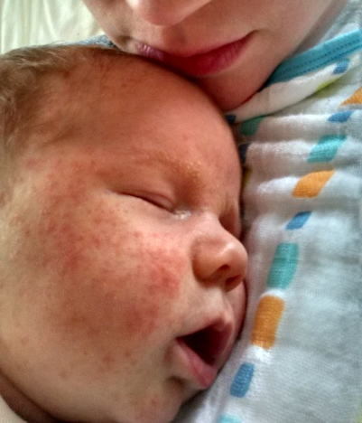
This is Max at just one month old – the very beginnings of his eczema:

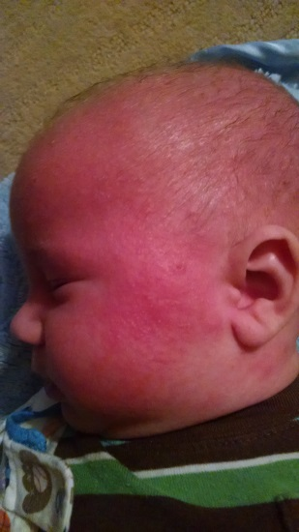
This is Max when his eczema got to its worst, around 3 months old. It’s hard to tell from the picture, but the skin on his face, arms and calves was oozing.

Dr. Jen, Stephanie, Jenn Browner, and all of the staff have been so very supportive throughout all of this! After trying some dietary changes through my nutrition program to improve my breastmilk for Max, we didn’t see too much of an improvement with his skin. After his second ear infection, Dr. Jen decided to dig deeper and found that Max was a candidate for the allergy clearing program. He showed allergies to almost every item in the allergy kits. About 6 weeks ago, we started the allergy clearing. We’re almost half way through the program and the change and improvement we’ve seen with our sweet boy is AMAZING. After about 3 weeks, we started to see improvements in the severity of his eczema. It started disappearing. I have used over a dozen different creams and lotions on Max’s skin, multiple times per day for his entire life. At this point, his skin is so dramatically improved, I’m only using coconut oil and an all natural ointment and only use it after bath time! He’s finally sleeping like a “normal” 5 month old- just waking us up a couple times per night for a snack! The biggest change that we are so grateful for is that his temperament has taken a complete 180. Max has been so uncomfortable, itchy and painful his whole life that he was almost constantly crabby and tense. Now, he is SUCH a happy and relaxed boy. He’s catching up developmentally on all of his skills and plays so peacefully with us! Sometimes, when I’m putting lotion on Max, I’m moved to tears because of how clear and soft his skin is becoming. After seeing him suffer for so many months and feeling so helpless to do anything, it feels amazing to be able to help him!
This is Max now!!!
We’re so grateful for this journey and for Lakeland!

