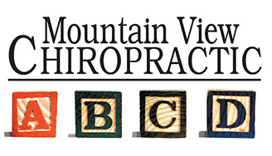

Light Therapy Guidelines
- Do not eat 2 hours before or 2 hours after each treatment. Reason: Your liver needs to work on clearing the fat mobilized during the treatment, rather than the calories you’re eating.

- Exercise immediately after each treatment. We have a vibration plate in office for your use, or you can do your normal workout elsewhere. High Intensity Interval Training (HIIT) works best. Reason: The Contour Light treatment is releasing stored fat into the body. We need the fat to be processed by the lymphatic system and liver rather than deposited back into your cells.

- Stay hydrated before and after treatments. Our recommendation is half of your body weight in ounces of water per day. Please drink at least two 12 oz glasses an hour prior to treatment. Ensure that you use the restroom before your treatment. Reason: The more hydrated your cells are, the more fat they will dump.

- To maximize your results, no alcohol within 10 hours of treatment. Reason: Alcohol interferes with proper liver function.

- No lotions or creams on the body parts that will be treated. Reason: Lotions and creams will reflect light away from the body; for best results, we want the body to absorb as much light as possible.

- What to wear during treatment? Bathing suit or under garments depending on your comfort level. Keep in mind where you would like to target or lose inches, the light has to be emitting the skin of those areas. Reason: The light does not penetrate through clothing.

- Treatments cannot be scheduled within 48 hours of each other. We do see best results when 2-3 treatments are done per week.

- The light works best when combined with healthy eating. We recommend an ancestral diet based on three core pillars. Elimination of:
  - Grains: breads, pastas, cereals, etc.
  - Sugars and highly processed foods
  - Seed oils: sunflower, canola, safflower, soybean, etc.
Work to only eat in a window of about 7-10 hours per day and have around 35-45 grams of animal-based protein per meal.

