What is Keto? Primer.
Special report from Ketonutrition.org
What is Ketosis?
Ketosis is the metabolic state defined by elevation of ketone bodies. It’s generally accepted that one is in ketosis when blood levels of the primary ketone body, beta-hydroxybutyrate (BHB), reach above 0.5 mmol/L. With the exception of ketosis induced via exogenous ketone supplements, this metabolic switch takes place in low glucose and therefore low insulin states. When we stop eating carbohydrates or begin a fast, the body burns through its available glucose stores, insulin levels will fall, the glucose stored in our liver (glycogen) becomes depleted, and slowly the body transitions into a fat-burning state. The brain cannot rely on fat for fuel, but needs an alternative energy source in the absence of glucose, so the liver instead converts fats to ketones. These ketones enter circulation and are delivered to our tissues for fuel.
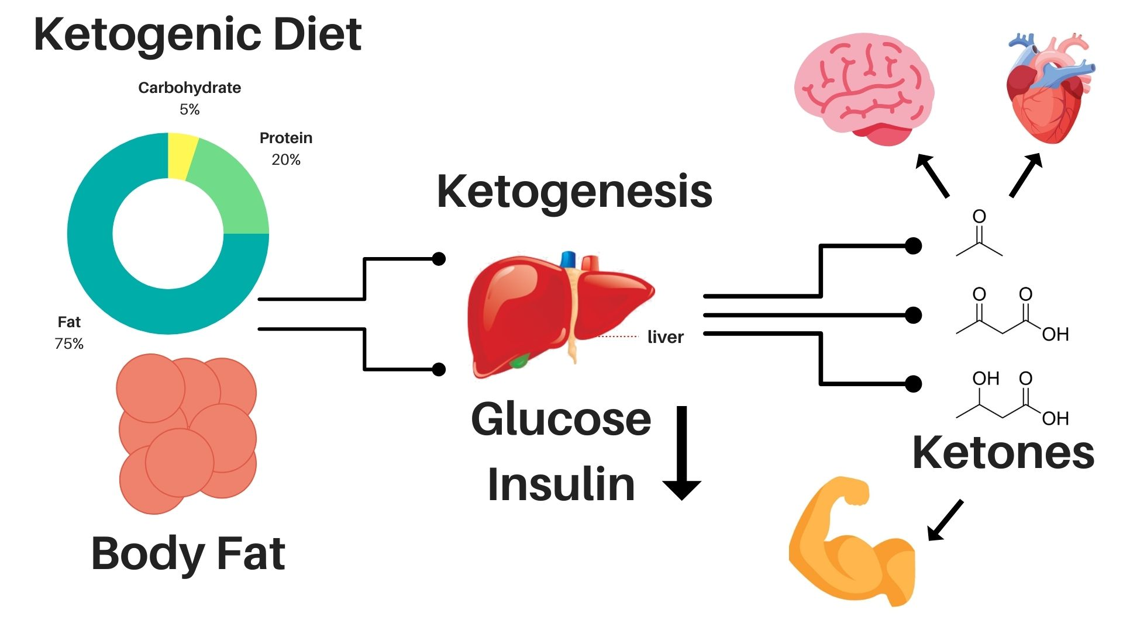
What is a ketogenic diet?
In a nutshell, a ketogenic diet is a very low carbohydrate, moderate protein, high-fat diet that switches the body from burning primarily sugar, to burning primarily fat and ketones (ketosis). The ketogenic diet is unique in that it’s the only diet defined by the presence of a biomarker: blood, urine, and breath ketones, and these markers are used to define ketosis.
The diet was first introduced in the early 1920s as a way to mimic fasting for therapeutic purposes. The original ketogenic diet equated to roughly 90% calories from fat, 6-9% from protein, and next to no carbohydrates, around 0-4%. While this diet is really effective at inducing ketosis, for the average person just looking to optimize their health, this level of stringency is not required nor is it always best practice.
The more the diet is being adopted, the more the ketogenic diet is becoming an umbrella term to describe variations of low carbohydrate diets that promote ketosis. In other words, there is more than one way someone can follow a ketogenic diet. Modified versions allow for more liberal amounts of protein which make the diet much more sustainable, enjoyable, and has advantages if your goal is improving body composition. It’s also clear that there are several factors that affect ketosis. For example, someone who is starting a ketogenic diet for weight loss, who may have some underlying metabolic damage, and lives a sedentary lifestyle will need to restrict carbohydrates to a much greater degree than someone who is lean, active, and metabolically flexible.
The general, more liberal, macronutrient breakdown, and a good place to start, works out to around 30-60 grams of total carbohydrates a day, ideally coming from fibrous vegetables, 1.2-2.0 grams of protein per kg ideal body weight, and the remainder of calories from fat typically recommended to be eaten to satiety or to your calorie needs.
What can you eat on a ketogenic diet?
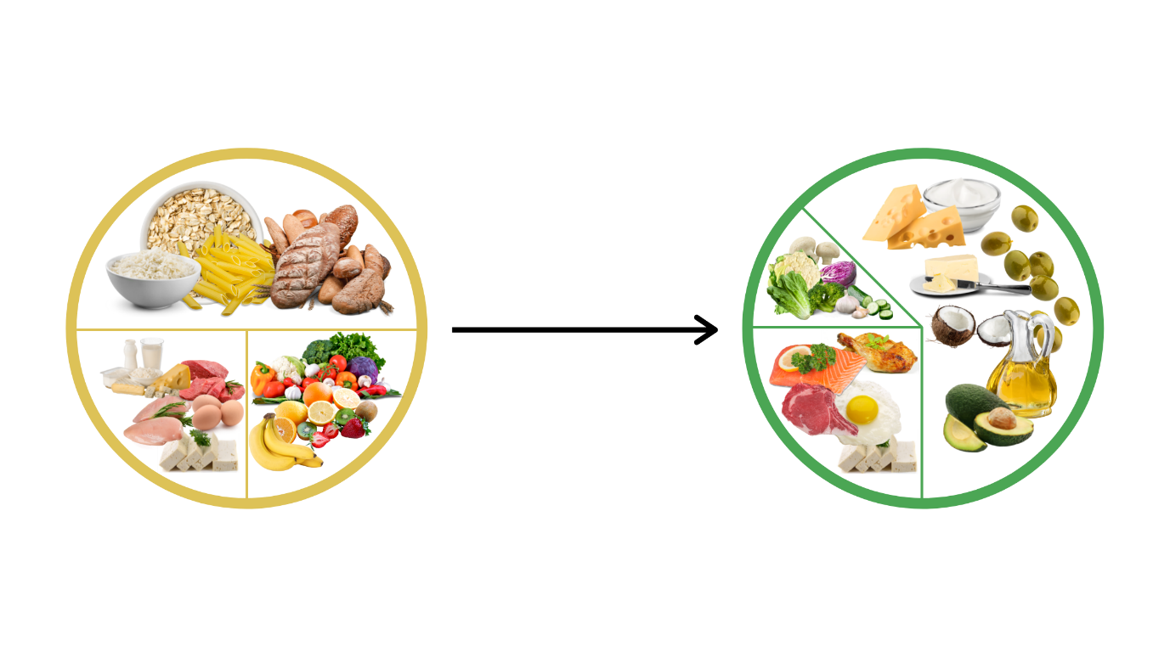
As we’ve mentioned, there are many different ways to follow a ketogenic diet. We are strong advocates of well-formulated ketogenic diets based around whole, nutrient-dense foods.
- Fatty cuts of meat, poultry, fish
- Eggs
- High-fat nuts, seeds, and nut butters (e.g. macadamia nuts, pili nuts, hemp seeds)
- Low-carbohydrate fibrous vegetables (e.g. leafy greens, lettuces, broccoli, cauliflower, cabbage, Brussel sprouts, celery, zucchini, cucumber, mushrooms)
- Quality oils and fats (e.g. avocado oil, coconut oil, extra-virgin olive oil, grass-fed butter or ghee, lard, tallow, MCT oil)
- Low-sugar fruits (e.g. olives, avocados, berries, coconut)
- Full-fat dairy products (cheese, heavy cream, full fat yogurt, etc.)
- Non-glycemic sweeteners (stevia, allulose, monk fruit, erythritol, xylitol)
Don’t overcomplicate it! Building ketogenic meals can be as simple as choosing a protein source, cooking in your favorite herbs and spices, and eating it alongside a simple veggie dish with quality oils and fats. Breakfasts can be as easy as bulletproof coffee, black coffee for intermittent fasters, or some eggs, avocado, and sauteed spinach. For dessert, consider just a block of 90-100% dark chocolate, some blueberries in full fat yogurt or heavy cream, or try experimenting with some low carb baking. The internet is filled with amazing free resources and recipes. We recommend Caroline’s Kitchen and The Castaway Kitchen to start.
What should you absolutely avoid?
Food groups that we recommend avoiding if trying to sustain ketosis are:
- Legumes
- Grains (e.g. whole-grains, rice, oatmeal, flours, etc.)
- Sugary treats (cookies, cakes, pastries, breakfast cereals, etc.)
- Sugar/sweeteners (e.g. refined sugar, honey, maple syrup, coconut sugar, agave)
- Sodas, juices, any sugar-sweetened beverage
- High-sugar fruits
- Starchy vegetables (e.g. potatoes, beets, carrots, yams)
For those who aren’t ready or want to follow a strict ketogenic diet, there are benefits to low carb diets that aren’t necessarily ketogenic that still include small amounts of whole-food carbs (foods higher in carbohydrates that are found in nature!). Some people may find they feel great adding in some of these whole food carbs periodically depending on one’s carbohydrate tolerance, or pre-exercise for more high-intensity (glucose-demanding) exercise or post-exercise when our muscles are primed and ready to soak up glucose from the bloodstream.
What about alcohol?
There are some low-carb wines (we love Dry Farm Wines) and drinks available that can be enjoyed on a ketogenic diet that can be ok to consume in moderation and limited amounts. Of course, sugar-sweetened cocktails and sweet wines such as port and dessert wines are high in sugar and should be avoided. Hard alcohols such as whisky, tequila, and vodka are another low-carb option and can be mixed with unsweetened/sugar-free beverages.
“Keto-Friendly”: To Trust or Not to Trust?
While we generally recommend you stick to mostly whole-foods, we love that there are so many keto packaged products that are available that help improve adherence to a ketogenic diet. However, not all “keto-friendly” foods are suitable for a ketogenic diet.
If the ingredients listed are in line with the “foods to eat” above, then most likely they are a good option! Lots of great keto packaged foods will include some combination of nuts and nut flours, non-glycemic sweeteners, healthy fats, and maybe some protein powder or eggs. Flavorings, baking soda/powder, extracts are generally not going to be an issue as far as ketosis goes, so long as they don’t contain sugar.
A few ingredients to look out for that could be secretly sabotaging your ketogenic diet:
- Maltitol: A sugar alcohol used in many “keto” products, but actually causes a rise in blood sugar.
- Isomalto-oligosaccharide (IMOs): A type of “resistant starch” that is not as resistant as people think. IMOs are partially digested and cause a rise in blood sugar.
- Sugar: this seems obvious, but some ketogenic packaged foods still include small amounts of sugar.
- Starchy carbohydrates such as tapioca flour, rice flour, and cassava flour are all carbohydrate based alternatives to wheat flour that are found in many health foods but are not really conducive to a ketogenic diet.
Top tip for choosing packaged low carb foods is to read the ingredients, do not rely on whether it is marketed as keto. If it contains sugar or any other sneaky alternative to sugar (syrups, fruit juices, cane juice, dextrose, among others), put it down. Lastly, make sure there aren’t any sneaky starchy carbohydrate sources.
Common faults
Carb creep
If you are unfamiliar with the carbohydrate content of the foods you are eating, then it is very easy to eat more carbohydrates than you should be to reach and sustain ketosis. You might think you are eating a ketogenic diet but those handfuls of cashews, too many blueberries, and a few too many carrot sticks can be the difference between a low carb and a ketogenic diet. Tracking your macros with an online/mobile app can be really handy in the beginning stages of a ketogenic diet while you work out the kinks of the diet.
Junk food keto
Sometimes counting and tracking carbohydrates can backfire when it comes to food choices. See, if your only goal is to hit a certain macro target, it might be a lot easier for you to grab a “keto” bar alongside a ready to go keto shake off the shelves than it is to measure how many carbs are in a whole-foods based ketogenic meal with no nutritional label to turn to with ease. Or, maybe you just live a fast-paced life and relying on fat bombs and bacon as your main two food groups for sake of time. While you may be technically following a ketogenic diet in both cases, a whole foods based ketogenic diet will certainly lead to better health. While there’s nothing wrong with having packaged keto foods, they shouldn’t be where the majority of your calories are coming from.
Fearing carbs from fibrous vegetables
This mistake may also be related to counting and tracking macros where you are so focused on reducing carbs that those 5g of carbs in your broccoli or brussel sprouts make you hesitant to even eat vegetables. Low carbohydrate vegetables, even though they do contain carbohydrates, they are mostly fibre. While fibre is technically a carbohydrate, it is not fully broken down during digestion and passes through our digestive tract without being fully absorbed. Fibre comes in two forms: soluble and insoluble. Soluble fibre, the type primarily found in fruits and legumes, is fermented in the gut and produces short-chain fatty acids that are used as fuel by the cells that line the gut. Insoluble fibre, the type found mostly in non-starchy vegetables, is the type that passes through digestion relatively unchanged and the type that you will be consuming most with plant-based low carb foods. Keep in mind that 20g of carbohydrates from a sugar-sweetened food is not the same as 20g of carbohydrates from spinach. The latter of which shouldn’t deter you from eating vegetables, as these fibre-rich foods are digested very slowly (especially if they are raw), and won’t release glucose into your system like sugar will. Vegetables are an important component of a well-formulated ketogenic diet, and shouldn’t be feared as you may be able to eat more total carbs than you think when they are coming from just fibre-rich vegetables.
Eating too little protein
Another common fear is that too much protein will inhibit ketosis, which leads people to restrict protein. It’s true that too much protein can inhibit ketosis, however, consuming adequate protein is really important for body composition, feeling satiated after a meal, and maintaining muscle mass throughout the lifespan, especially if you are eating in a calorie deficit. So, it is in your best interest to make sure you aren’t opting for more fat calories over protein calories in fear of kicking you out of ketosis. You can eat above the RDA, which is set at 0.8g/kg body weight and still be following a ketogenic diet.
Not replenishing lost electrolytes
The infamous “keto flu” is often the result of electrolyte imbalances caused by the loss of electrolytes that haven’t been replenished. Ketogenic diets lower insulin, which reduces the uptake of sodium from the kidneys, and this leads to mild sodium depletion and imbalances of potassium and magnesium, too. The common symptoms of electrolyte imbalances are headaches, fatigue, sleep disturbances, among others. Make the transition into a ketogenic diet as comfortable as possible by making sure you are consuming enough sodium with your food or supplementing with electrolytes, sugar-free of course! A great product that can help during the transition to avoid the “keto flu” is KetoStart from Audacious Nutrition, which contains high dose of beta-hydroxybutyrate to elevate ketone levels, while you are restricting your carbohydrate intake, but your body does not produce ketones yet, while this product also contains the optimal electrolyte mix, so you basically get two products in one.
Misconceptions about the ketogenic diet
- Keto is bad for heart health
The first thing people think of when they think of heart disease is LDL-cholesterol, the so-called “bad cholesterol”. And, in some cases, those who switch to a ketogenic diet will see a rise in LDL-cholesterol. However, this is often in the context of higher HDL-cholesterol, the so-called “good cholesterol” and significantly lowered triglycerides (this is a really good thing!). Whether or not a rise in LDL when everything else seems to me moving in the right direction increases one’s risk of heart disease is a hotly debated topic, and there is ongoing clinical studies addressing this very question. Keep in mind that LDL-cholesterol is a marker of how much cholesterol is carried in LDL particles. Each LDL particle carries one apoB protein, and it is apoB-containing lipoproteins that transfer cholesterol into the arterial wall (the starting stages of atherosclerosis). So, if you are able to get an aboB measurement, this will provide more information on the atherogenic risk. Moreover, a meta-analysis from 2016 suggests that despite a potential increase in LDL with low carb diets, the other advantages and health improvements may outweigh low-fat diets. In any case, some people find success with lowering LDL-cholesterol on a ketogenic diet by substituting saturated fat for more polyunsaturated fats and following a more mediterranean based keto diet. Ultimately, by improving your metabolic health with a keto diet, improving insulin sensitivity, and optimizing body composition, you are lowering your risk of heart disease.
- Keto diet is bad for gut health
Sure a keto diet could be bad for gut health, just like a vegan diet full of junk food could be, too. There is nothing inherently “bad” about a ketogenic diet for the gut. Many people are concerned that a keto diet limits fiber intake, but you can eat plenty of dietary fiber while maintaining ketosis, as many low-carb vegetables contain loads of soluble fiber to feed the gut microbiome. But, some people actually seem to do better with less dietary fiber, and actually reverse gut issues by removing all plants from their diet. Moreover, ketone bodies can fuel the cells that line our gut in the absence of short chain fatty acids produced from dietary fiber. The gut microbiome is a lot more metabolically flexible than we might think! Lastly, high-fat diets are often viewed as detrimental to gut health, but this is largely stemmed from research linking “high-fat western diets” aka high-fat junk food diets to gut dysbiosis, which is not a fair comparison to a well-formulated high fat ketogenic diet. We highly recommend you check out this review article for further reading!
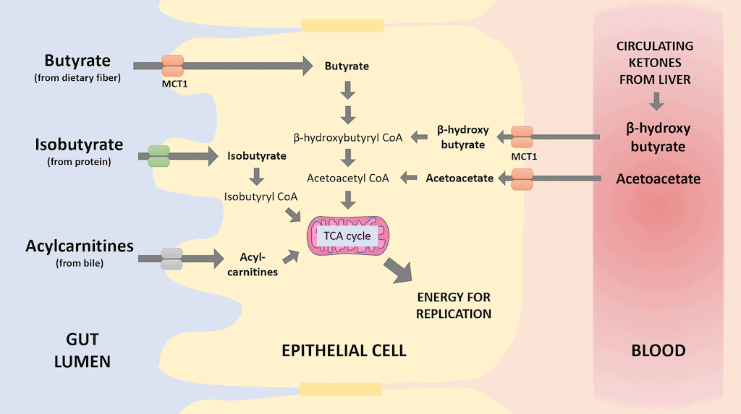
- Athletic performance will suffer
This is only partially a misconception, as it’s certainly true that carbohydrates are the dominant fuel for high intensity exercise. That said, carbs are not as essential as once believed, and this is especially true for endurance based sports. Ketogenic diets can be a great tool for improving endurance performance, where the majority of the event is fueled by fat. By improving your muscle’s ability to burn fat in the face of limited glucose availability, you are more resilient against fatigue due to reduced reliance on glucose, and ability to spare glycogen. Additionally, performance may decline regardless of the sport when first getting started on a ketogenic diet. Over time the body gets better at mobilizing and burning fats and ketones, progressively becoming more “keto-adapted”. With keto-adaptation, performance may, and will likely return to baseline, even with high-intensity exercise. For the average person just looking to optimize their health with a ketogenic diet while still hitting it hard in the gym, consider cycling whole food carbohydrates around training and tinkering with what works best for you to feel your best.
- Keto leads to hormonal imbalances
Oftentimes, individuals, especially females, are concerned that a ketogenic diet will threaten their hormonal health. There is some evidence, highlighted in our previous blog post, that a ketogenic diet can lower thyroid hormones, but researchers suggest that this is due to greater sensitivity to active thyroid hormone (T3) similar to how we improve sensitivity to insulin or leptin, therefore needing less. Regarding sex hormones, similar to thyroid activity, overall caloric intake matters, often independent of macronutrient intake. If you are chronically undereating, which is a real risk with ketogenic diets due to their appetite-suppressing effects (and why they can work well for weight loss!), you do run the risk of hormonal imbalances. This can be exacerbated by excessive exercise and fasting for both males and females. The effects of a low carb diet will vary depending on where you are in terms of metabolic health and how you formulate your diet. Including lots of healthy fats and enough protein will likely be of critical importance when it comes to hormonal health while following a ketogenic diet.
Key tips for going keto
- Clear your kitchen and pantry of tasty temptations
Try your best to rid the house of refined-sugars, grains, grain-based foods such as pastas and breads – out of sight, out of mind! Start transitioning to a whole foods diet, slowly weaning off of starchy veg and fruits. We recommend adding in some MCT oil or exogenous ketones during this time to introduce your body to ketones, to make the transition seamless before your liver starts ramping up its own ketone production.
- Get used to (healthy) fats
If you have an inherent fear for fats, it might be difficult for you to accept a ketogenic way of eating. If you can’t eat carbs, you’re only limited in how much protein you can eat, and you’re afraid of fat, well then there’s nothing left for you to eat! Start with whole food sources of fats, like eggs, dairy, avocados, fatty fish and meats, and start incorporating high quality oils and fats to your foods.
- Get comfortable eating keto on the go
Let’s be honest, we all live fast-paced lives and there will be times when you’re in a pinch and need to eat on the go. Eating out doesn’t have to be stressful though. In fact, keto might be one of the easiest “diets” to accommodate while eating out. Try and stick to whole food menu items, and you might just have to make some substitutions here and there. For example, subbing steamed vegetables in for rice, or asking for the burger without a bun. Avoid grains and starches, deep-fried or breaded items, salad dressings (opt for olive oil and vinegar/lemon juice if they can accommodate that!), and sauces (often loaded with sugar).
- Avoid the common mistakes listed above
Be aware of how many carbohydrates you are consuming, stick to whole foods as best you can, eat your veggies and adequate protein, and keep your electrolytes in check!
- Choose your supplements wisely
Replenish your electrolytes and to help the transition or to get back into ketosis after a cheat meal you can use exogenous ketone supplements (e.g. KetoStart).

Written by: Kristi Storoschuk, Edited by: Dr. Dominic D`Agostino, Dr. Csilla Ari D`Agostino

