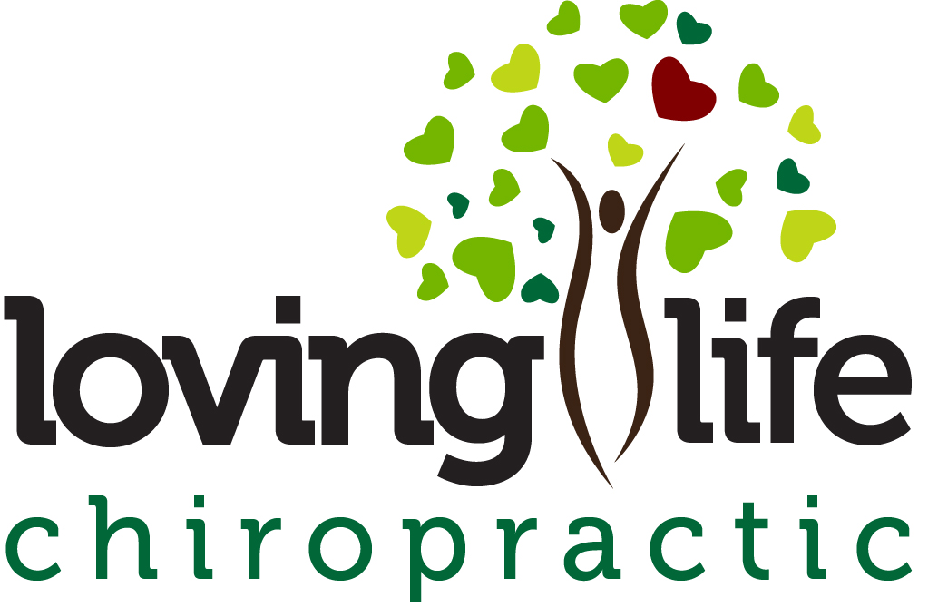
14 HIGH PROTEIN
MAIN MEALS
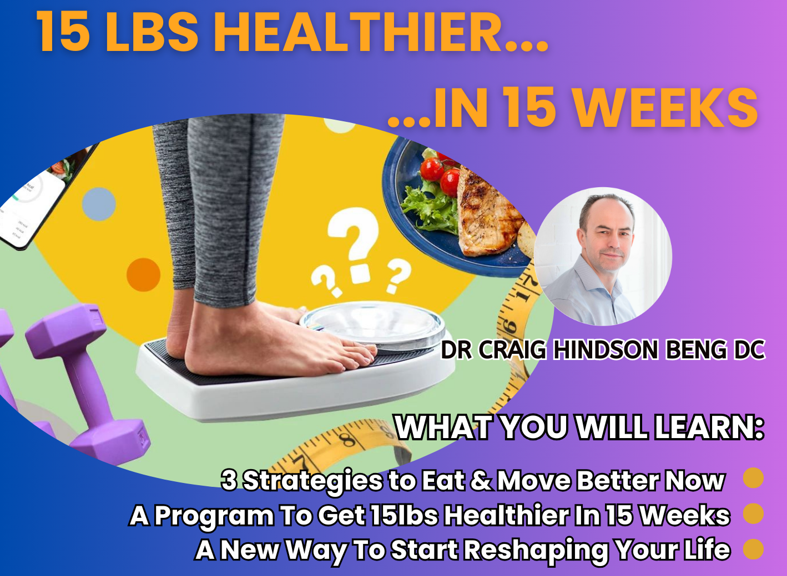

14-Day Keto High-Protein Dinner Plan
This printable guide includes a full 14-day keto-style dinner plan with complete recipes. Each meal is high in protein, low in carbohydrates, and designed to support metabolic health and satiety.

🗓️ 14-Day Keto High-Protein Dinner Plan
Day | Meal
1 | Garlic Butter Steak & Broccoli
2 | Creamy Tuscan Chicken Thighs
3 | Lemon Dill Butter Salmon
4 | Keto Meatballs & Zoodles
5 | Pork Chops with Creamed Spinach
6 | Bunless Cheeseburger Skillet
7 | Lemon Butter Cod & Green Beans
8 | Chicken Alfredo (Zoodle Style)
9 | Rosemary Garlic Lamb Chops
10 | Keto Stuffed Bell Peppers
11 | Garlic Butter Shrimp Skillet
12 | Braised Beef Short Ribs
13 | Chicken Bacon Ranch Skillet
14 | Keto Turkey Meatloaf

Day 1 – Garlic Butter Steak & Broccoli
[Insert meal image here]
Ingredients:
- 10 oz sirloin or ribeye steak
- 2 tbsp butter
- 1 clove garlic, minced
- 1½ cups broccoli
- Salt & pepper
Instructions:
Season steak. Pan-sear in butter 3–4 min per side. Rest. Sauté garlic briefly, add broccoli with splash of water, steam 4–5 min. Serve with garlic butter.
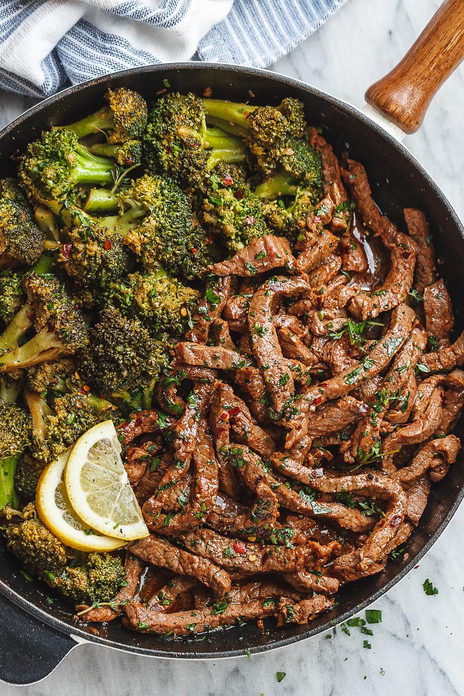

Day 2 – Creamy Tuscan Chicken Thighs
[Insert meal image here]
Ingredients:
- 2 boneless chicken thighs
- ½ cup heavy cream
- ¼ cup sun-dried tomatoes
- 1 cup spinach
- ¼ cup parmesan
Instructions:
Brown chicken. Remove. Simmer cream, tomatoes, parmesan. Return chicken, add spinach, cook until thickened.
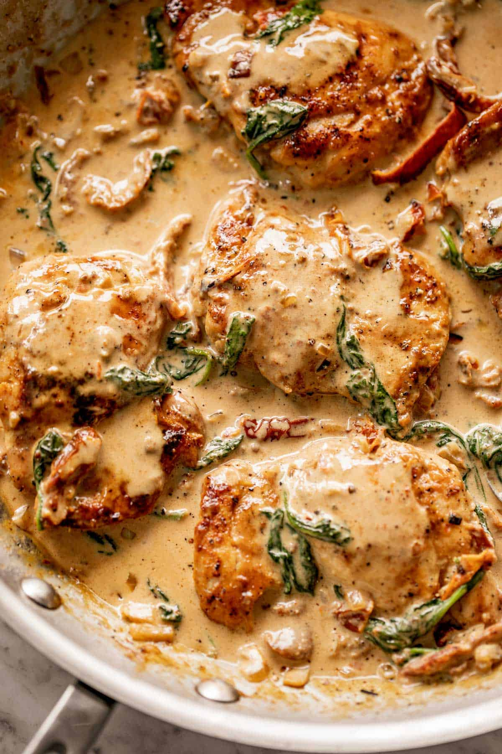

Day 3 – Lemon Dill Butter Salmon
[Insert meal image here]
Ingredients:
- 6–7 oz salmon
- 2 tbsp butter
- Lemon zest & juice
- Fresh dill
Instructions:
Bake salmon at 400°F for 12–15 min. Melt butter with lemon and dill. Spoon over salmon.
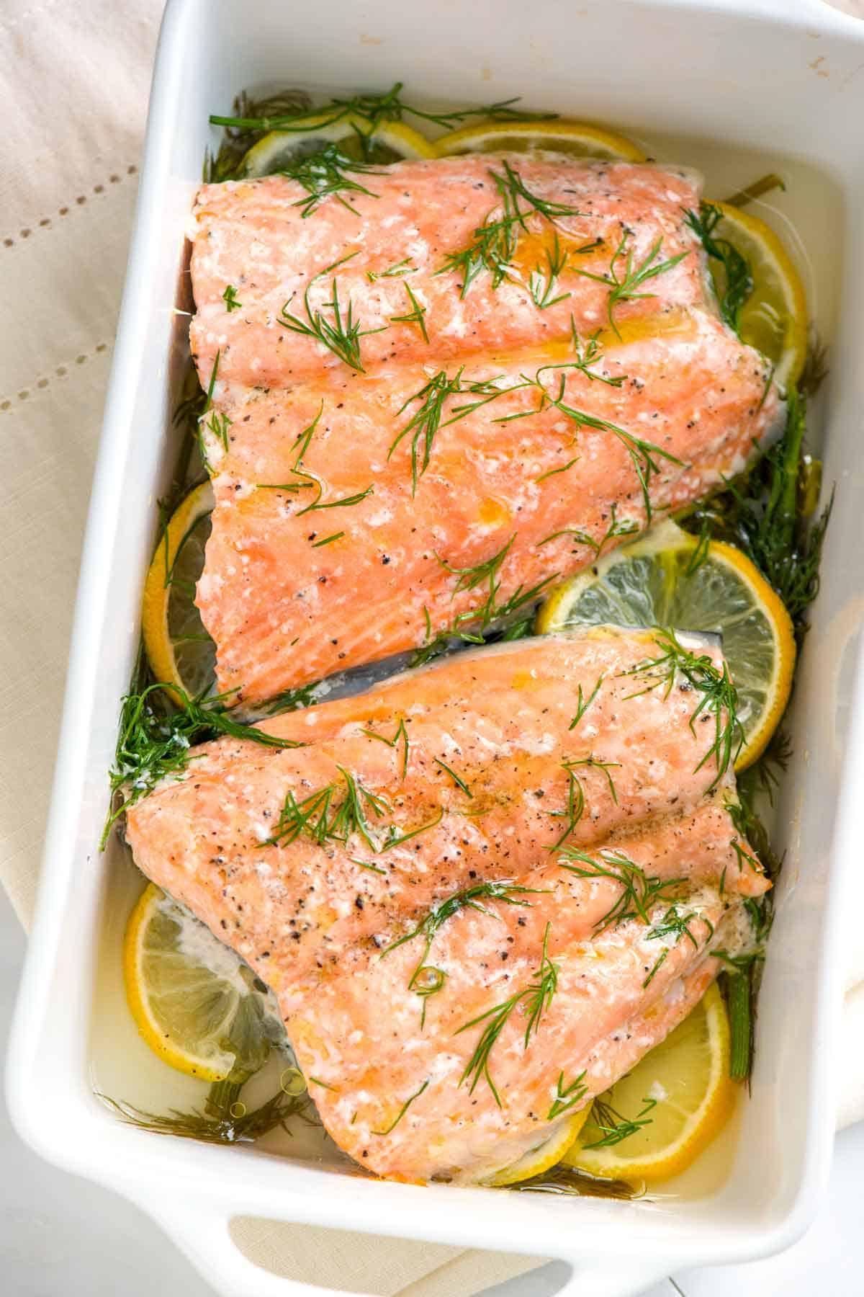

Day 4 – Keto Meatballs with Zoodles
[Insert meal image here]
Ingredients:
- ¾ lb ground beef
- 1 egg
- ¼ cup parmesan
- 1 tbsp almond flour
- 2 cups zucchini noodles
Instructions:
Mix meatball ingredients, form balls. Bake at 375°F for 20 min. Lightly sauté zoodles and serve.
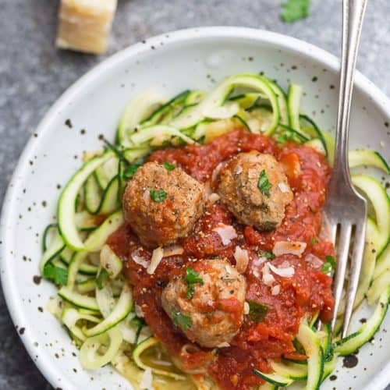

Day 5 – Pork Chops with Creamed Spinach
[Insert meal image here]
Ingredients:
- 2 pork chops
- ½ cup heavy cream
- 1 oz cream cheese
- 1 cup spinach
Instructions:
Pan-sear chops 4–5 min per side. Remove. Simmer cream and cream cheese, stir in spinach, serve.
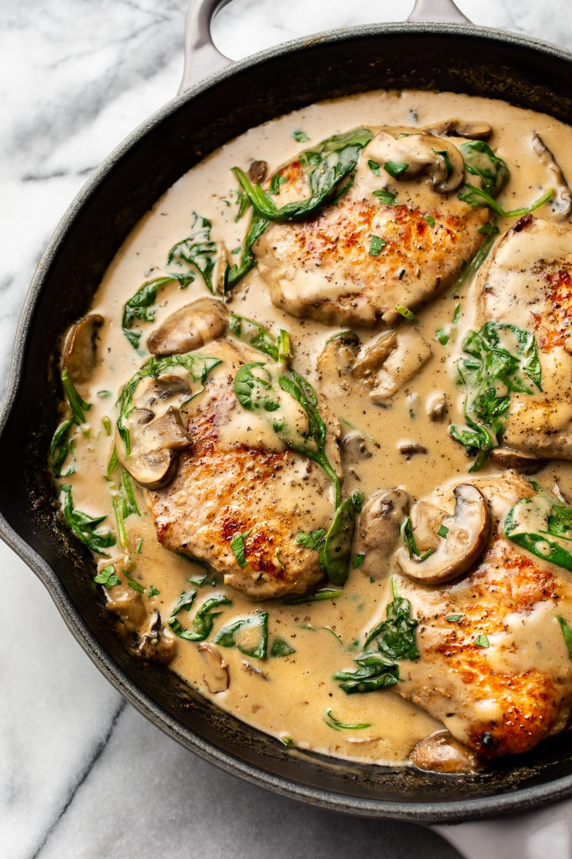

Day 6 – Bunless Cheeseburger Skillet
[Insert meal image here]
Ingredients:
- ¾ lb ground beef
- ½ cup shredded cheddar
- Pickles & mustard
Instructions:
Brown beef. Season. Top with cheese and melt. Serve with pickles and mustard.
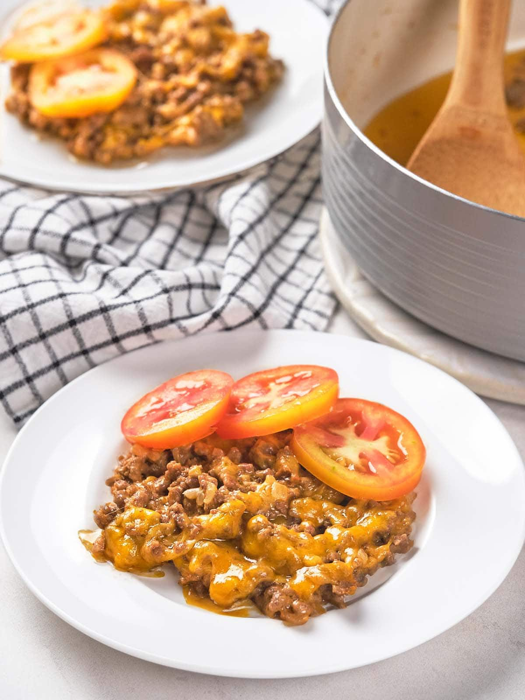

Day 7 – Lemon Butter Cod & Green Beans
[Insert meal image here]
Ingredients:
- 7 oz cod
- 2 tbsp butter
- Lemon juice
- 1 cup green beans
Instructions:
Bake cod at 400°F for 12 min. Steam green beans. Finish with lemon butter.

Day 8 – Chicken Alfredo (Zoodle Style)
[Insert meal image here]
Ingredients:
- 6 oz chicken breast
- ½ cup heavy cream
- ¼ cup parmesan
- 2 cups zucchini noodles
Instructions:
Cook chicken, slice. Simmer cream and parmesan. Toss with zoodles and chicken.


Day 9 – Rosemary Garlic Lamb Chops
[Insert meal image here]
Ingredients:
- 2 lamb chops
- Garlic, rosemary
- Butter
Instructions:
Season chops. Pan-sear 3–4 min per side. Finish with butter and herbs.
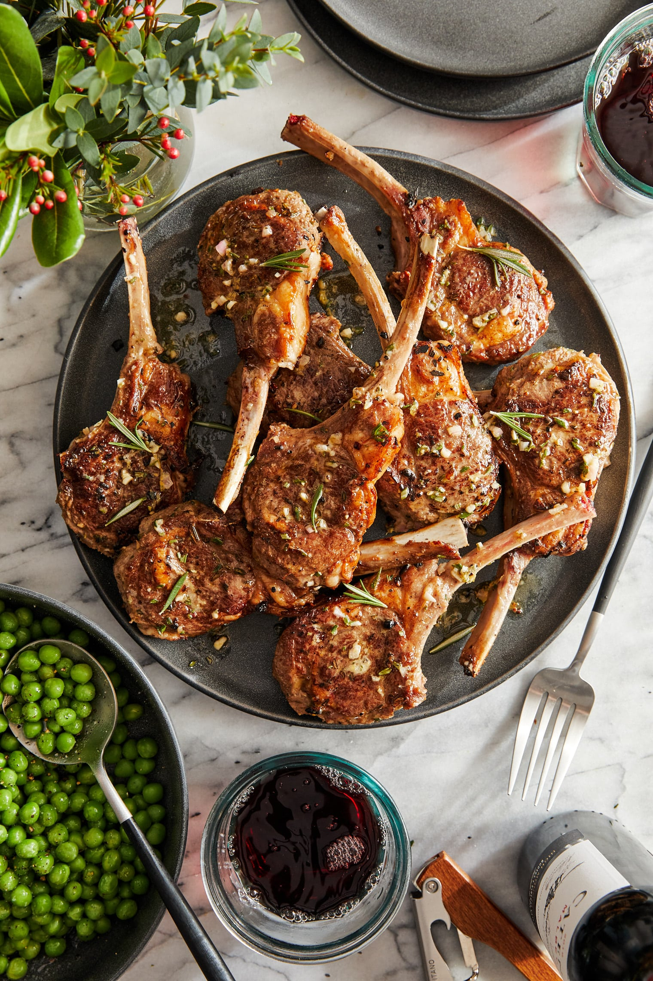

Day 10 – Keto Stuffed Bell Peppers
[Insert meal image here]
Ingredients:
- 2 bell peppers
- ¾ lb ground beef
- ½ cup cauliflower rice
- ½ cup cheese
Instructions:
Brown beef, add cauliflower rice. Stuff peppers, top with cheese. Bake at 375°F for 25 min.
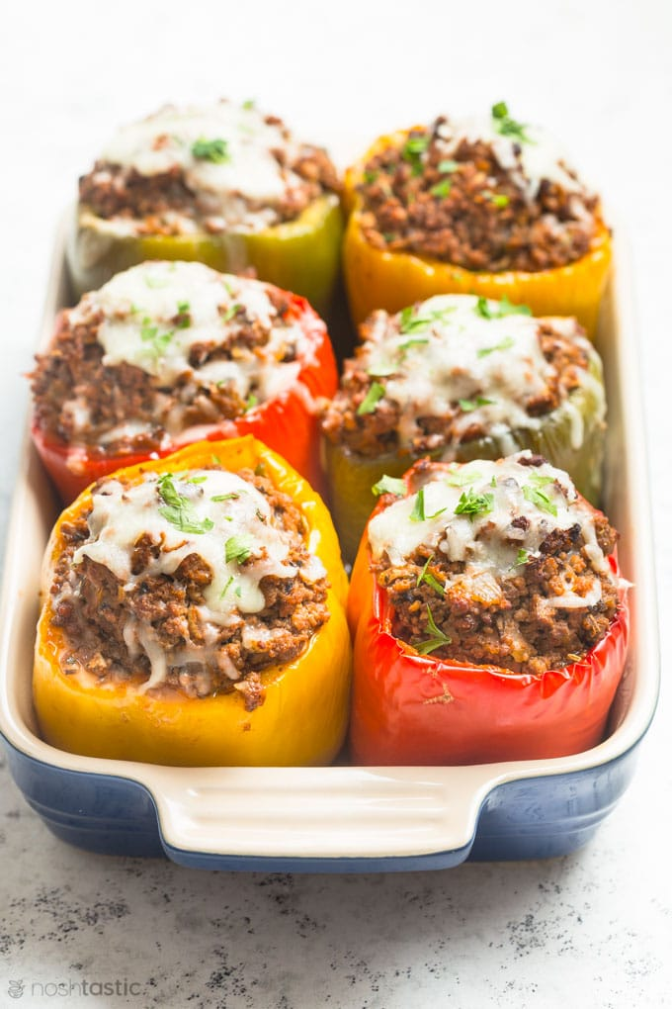

Day 11 – Garlic Butter Shrimp Skillet
[Insert meal image here]
Ingredients:
- 10 oz shrimp
- 2 tbsp butter
- Garlic, lemon
Instructions:
Sauté garlic in butter. Add shrimp 2–3 min per side. Finish with lemon.
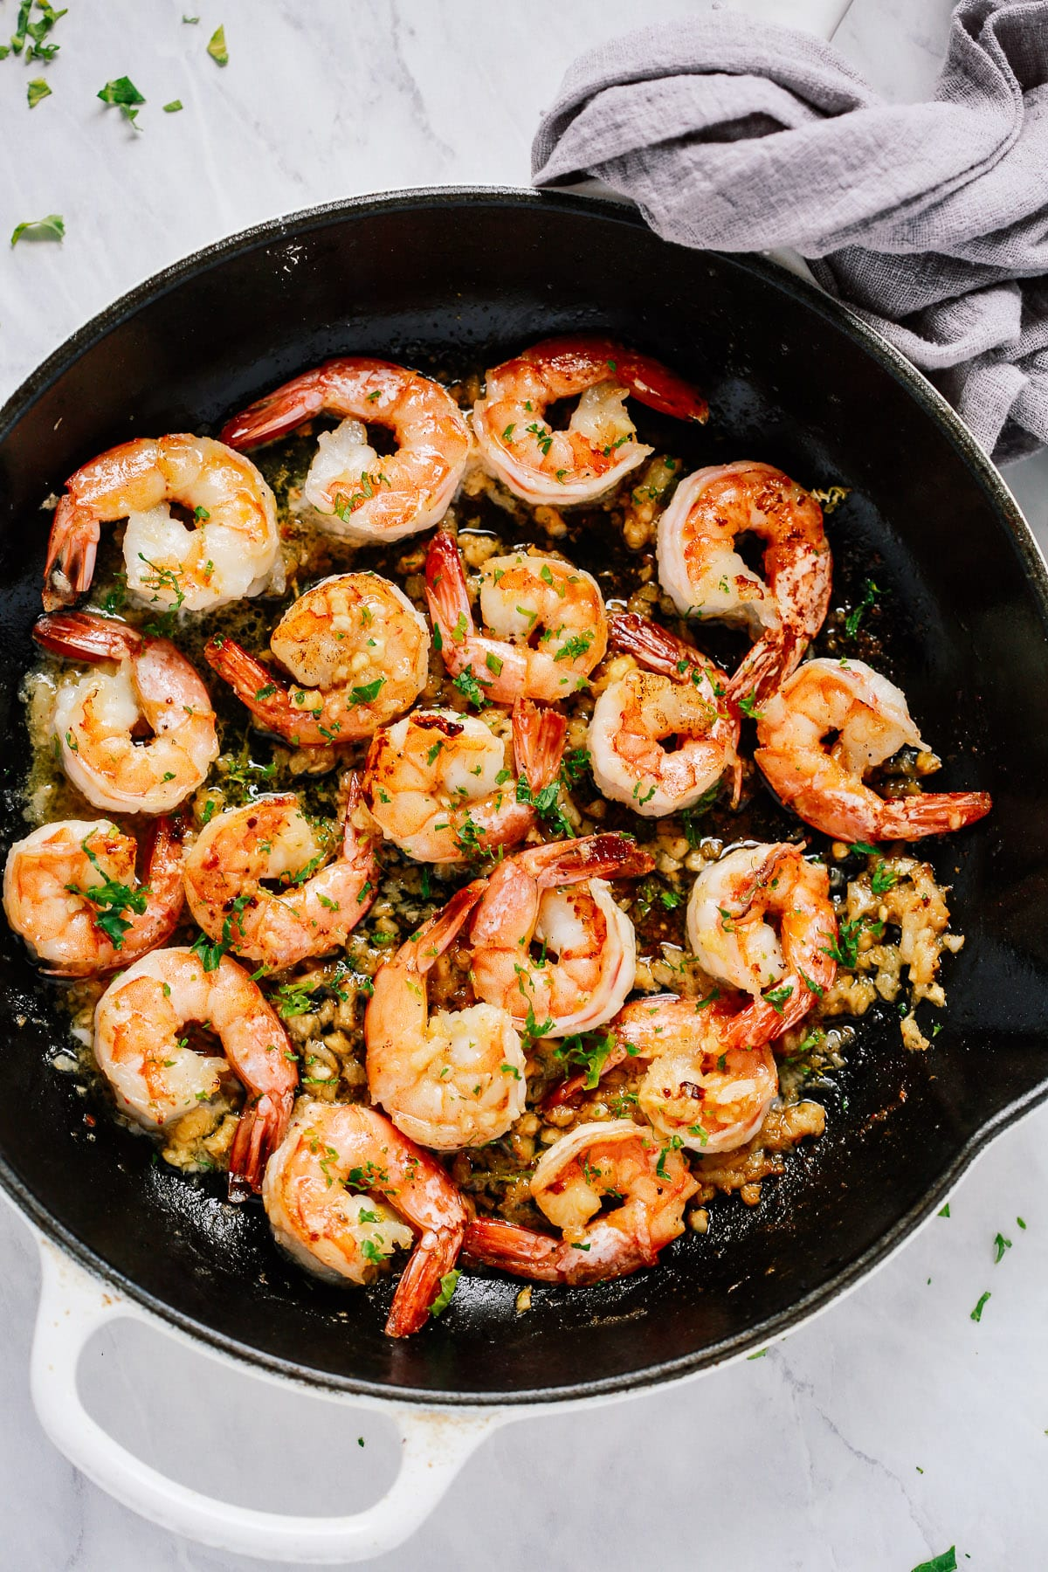

Day 12 – Braised Beef Short Ribs
[Insert meal image here]
Ingredients:
- 1 lb beef short ribs
- Beef broth
- Garlic, onion
Instructions:
Brown ribs. Add broth halfway up ribs. Cover and bake at 325°F for 2½ hours.
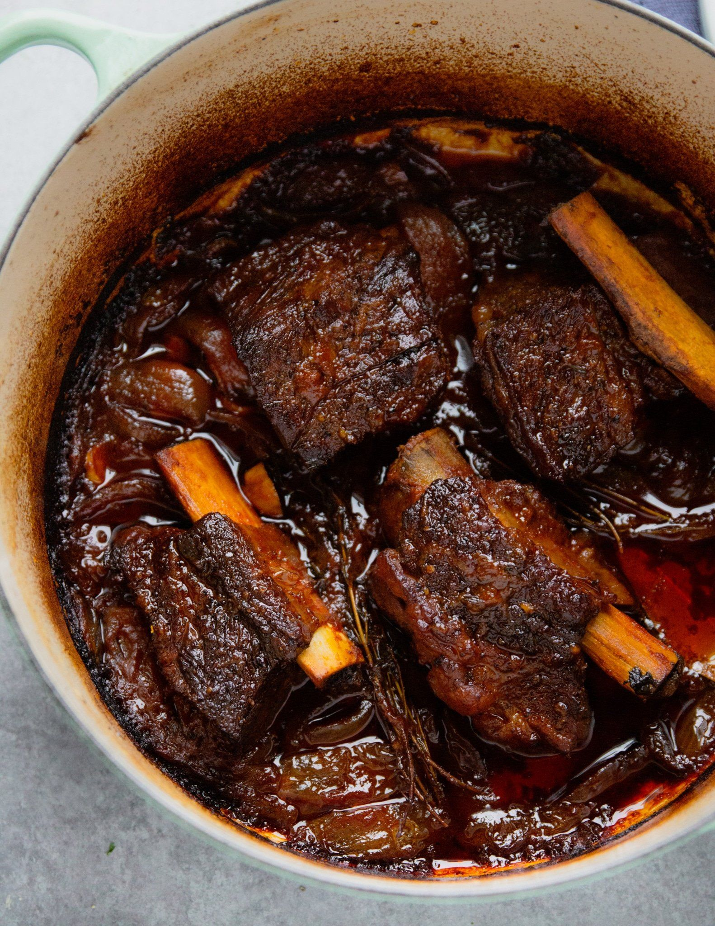

Day 13 – Chicken Bacon Ranch Skillet
[Insert meal image here]
Ingredients:
- Chicken breast
- Bacon strips
- ¼ cup cream
- Ranch seasoning
Instructions:
Cook bacon. Cook chicken in fat. Add cream, seasoning, crumble bacon in.
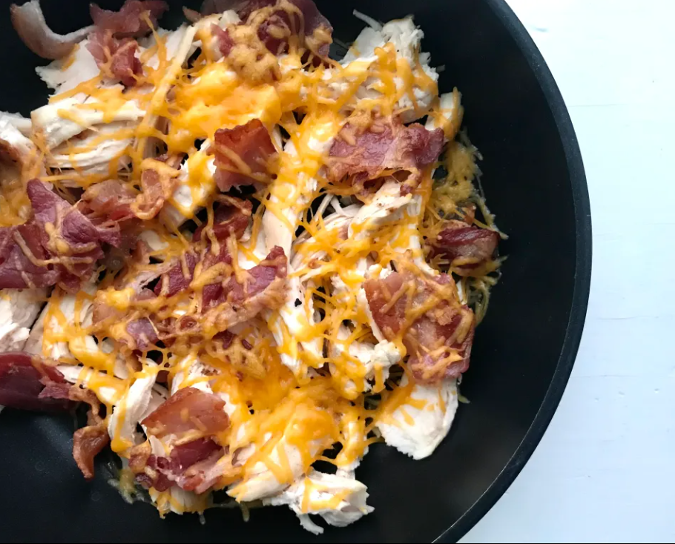

Day 14 – Keto Turkey Meatloaf
[Insert meal image here]
Ingredients:
- 1 lb ground turkey
- 1 egg
- ¼ cup almond flour
- Spices
Instructions:
Mix ingredients. Bake at 375°F for 45 min. Rest 5 min before slicing.

