Paul M. Bizzaro, D.C.
81 S. Main Street
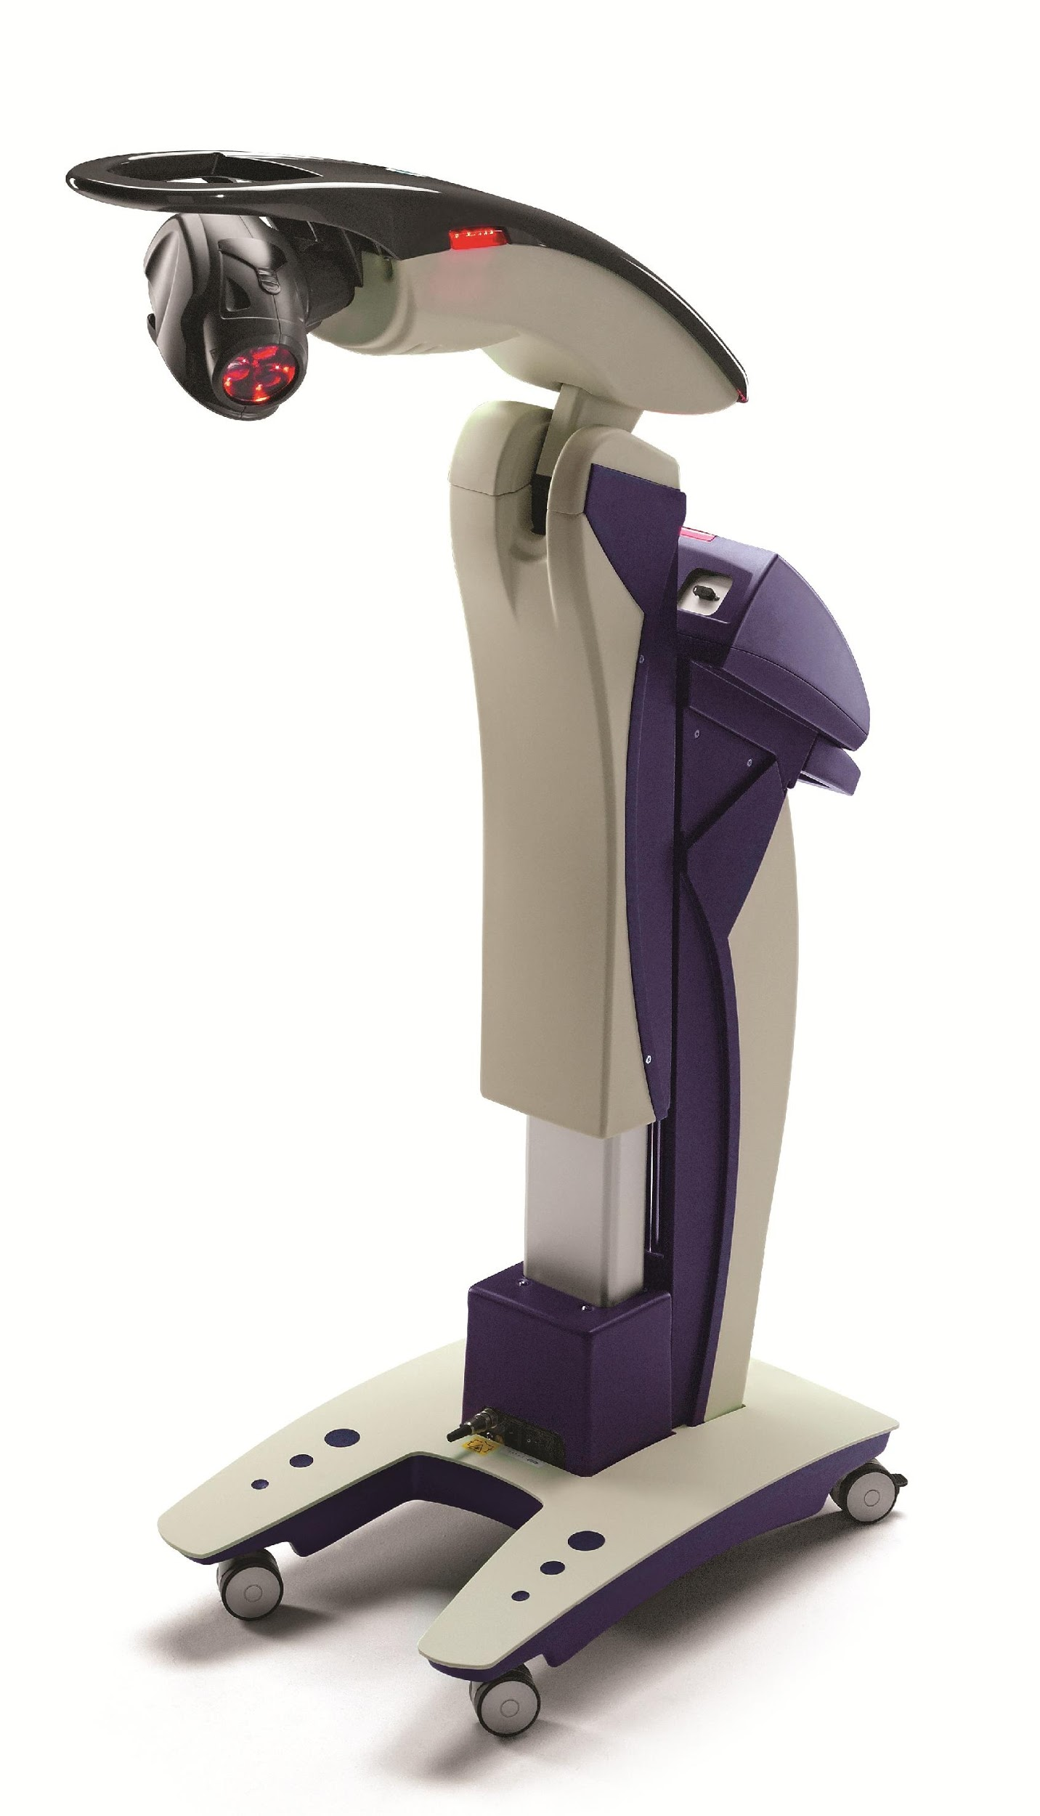
Yardley, PA 19067
Telephone: (215) 493-6589

Case History
MLS® Laser Therapy

Name: Last: __________________ First: __________________ M.I.: _____ Date: __________
Address: ____________________________________________________________________
City/State/Zip: ________________________________________________________________
Home Phone: ____________________Cell Phone: _______________Cell Carrier__________
E-mail address: _____________________________ Date of Birth: _____________ Sex: M or F
Occupation: __________________ Employer: __________________ Years Employed: ______
Is this condition employment related? Y/N Accident Related? Y/N Marital Status: M S W D
Emergency Contact: ___________________ Relationship: _________ Phone: _____________
Who referred you for MLS Laser Therapy: __________________________________________
How did you hear about MLS Therapy: _____________________________________________

What is you major complaint? __________________________________________________ ____________________________________________________________________________
Other complaints? _____________________________________________________________
How long have you had this condition? _____________________________________________
Have you had this or similar conditions in the past? Y/N, explain: ________________________
What activities aggravate you condition? ___________________________________________
Is this condition getting progressively worse? Yes No Constant Comes and goes
Is this condition interfering with your: Work Sleep Daily Routine Other: ____________
How long has it been since you really felt good? _____________________________________

Other Doctors seen for this Condition: MD DC DO DDS DPM
Doctor’s name: __________________________ Diagnosis: ____________________________
X-rays: _____________ Urinalysis: ___________ Blood Tests: ____________ Other: ________
Treatment: Medication: _____________________________ Physiotherapy: _______________
Results: ____________________________________ Length of time under care: ___________

Please list ALL surgeries within the last year: ________________________________________ ____________________________________________________________________________
Have you ever been involved in an auto accident? Y/N, explain: _________________________ ____________________________________________________________________________
Have you ever been involved in any other accidents? Y/N, explain: ______________________ ____________________________________________________________________________
Have you ever had any broken bones? Y/N, explain: __________________________________ ____________________________________________________________________________
Have you ever been diagnosed with cancer? Y/N, explain: _____________________________
Do you have an implanted neurostimulator device? Y/N, where: _________________________
Do you have a pacemaker? Y/N __________________________________________________
Are you currently taking any medications/supplements? Y/N, explain: _____________________ ____________________________________________________________________________
____________________________________________________________________________

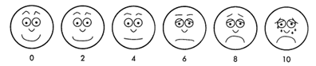

Use this chart to estimate your pain level (Circle One).

Please check any of the following that apply to you:

___ Take medication that increases sensitivity to sunlight ___ Take blood thinners
___ Have a seizure disorder that is triggered by light ___ Are pregnant
___ Have hemorrhagic diatheses ___ Have HIV positive history
___ Been injected with steroids in the past 2-3 weeks ___ Spinal Surgery
___ Leukemia

Please x any area of pain
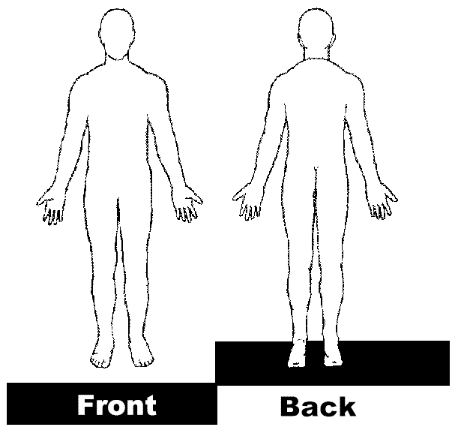

Patient Signature: ___________________________________________Date: _____________

Doctor’s Notes:_________________________________________________________________ ____________________________________________________________________________________________________________________________________________________________
______________________________________________________________________________

updated: 12.18

