Legal Name: ____________________________________________________________________________ Date: _____/_____/_____
Address: ____________________________________________ City: __________________________ State: _____ Zip: __________
Telephone Home: (_____) _______-___________ Work: (_____) _______-___________ Cell: (_____) _______-___________
We use text messaging for appointment reminders. Who is your cell phone company: _______________________________________
Email Address: _____________________________________________________ Social Security Number: _____-_____-_____
Preferred Name: ______________________________________________ Male _____ Female _____ Date of Birth: ____/____/____
If you are under 18 years of age, who are your legal parents or guardian?
Father/Mother/Guardian: ______________________________________________________ Phone: (_____) _______-___________
Who do you normally live with (check all that apply):
Father Mother Guardian/Foster Parent Grandparent(s) Brother(s)/Sisters(s) None of these
Marital Status:  Married Single Divorced Widowed
Spouse’s Name: ______________________ Number of children: ____ Names of children: __________________________________
Occupation: ______________________________________________ Employer: __________________________________________
Employers Address:__________________________________________________________ Phone: (_____) _______-___________
Student at _________________________________________________________________________ FULL-TIME  PART-TIME
Who should we contact in the event of an emergency? ________________________________________________________________
Phone: (_____) _______-___________ Address of contact person: __________________________________________________
Have you seen a Chiropractor before? Yes No If yes, when? ____________________________________________________
What is the reason for your appointment today: ___________________________________________________________________
_____________________________________________________________________________________________________________
_____________________________________________________________________________________________________________
Whom may we thank for referring you to our office? ___________________________________________________________________

YOUR HEALTH HISTORY

Please  check all symptoms you have ever had, even if they do not seem related to your current problem.
 Headaches | ❑ Pins and Needles in Legs | ❑ Fainting | ❑ Neck Pain
 Pins and Needles in arms | ❑ Loss of Smell | ❑ Back Pain | ❑ Loss of Balance
❑ Dizziness | ❑ Buzzing in ears | ❑ Ringing in Ears | ❑ Nervousness
❑ Numbness in Fingers | ❑ Numbness in Toes | ❑ Loss of Taste | ❑ Stomach Upset
❑ Fatigue | ❑ Depression | ❑ Irritability | ❑ Tension
❑ Sleeping Problems | ❑ Neck Stiff | ❑ Cold Hands | ❑ Cold Feet
❑ Diarrhea | ❑ Constipation | ❑ Fever | ❑ Hot Flashes
❑ Cold Sweats | ❑ Lights Bother Eyes | ❑ Problem Urinating | ❑ Heartburn
❑ Mood Swings | ❑ Menstrual Pain | ❑ Menstrual Irregularity | ❑ Ulcers

List all medications that you are taking: _____________________________________________________________________________
_____________________________________________________________________________________________________________
Date problem began: ____/____/____ Is it getting worse? Yes No Is it constant? Yes No Come and go? Yes No
Have you had a similar condition in the past? Yes No If so, when? _________________________________________________
What have you done for this problem? _____________________________________________________________________________
_____________________________________________________________________________________________________________
Have you had spinal X-rays, MRI, CT Scans? Yes No When: ____/____/____ Where: _________________________________
Have you been diagnosed with cancer? Yes No Year: ______ Type: _____________________________________________
Family history:  Cancer  Diabetes  High Blood Pressure  Cardiovasular Problems/Stroke
Is your condition or injury due to an accident or work-related cause?  YES  NO
Please check ALL that apply:
Did the condition or injury result from an automobile accident?  YES  NO
Did it result from a work-related accident or cause?  YES  NO Briefly Describe: ____________________________________
___________________________________________________________________________________________________________
**if you have answered YES to any of the above questions, please see the Front Desk for additional paperwork.**
WOMEN ONLY: Are you pregnant or is there any possibility you may be pregnant?  YES  NO  UNCERTAIN

Do you have health insurance?  YES  NO
Insurance Company: ___________________________________________________________________________________________
Full Name of Policy Holder: ________________________________________________ Policy Holder’s Date of Birth: ____/____/____
Is the insurance through his/her employer?  YES  NO If yes, who is the Employer? ________________________________
Primary Care Physician: ________________________________________________________________________________________
Phone: (_____) _______-___________ Address: __________________________________________________________________
It is our office policy that all services rendered are the responsibility of the patient, and that you are ultimately personally responsible for all payments regardless of whether or not this office accepts insurance assignment.

Ehlers Danlos (type IV) Marfan’s Disease – Marfan Variant Disorders:
Ehlers-Danlos and Marian’s Disease are genetic conditions that have been associated with injuries of the joints, connective tissues and blood vessels of the body. Other known, but yet-to-be named, genetic variants exist and are associated with similar risks. Medical studies have reported that blood vessel injuries of the neck known as cervical arterial dissections may occur spontaneously, with trivial traumas of the spine, in patients with high homocysteine levels, and/or during upper respiratory infections—particularly in these groups of patients. Have you been told that you have a connective tissue disorder? Yes / No

Informed Consent Form
What are the common side-effects of chiropractic care? Chiropractic is among the safest health disciplines in all of health care. Clinical studies have shown the most common side-effect of joint mobilization and joint manipulation/adjustment is mild, temporary local muscle soreness. The temporary soreness may be similar to what is experienced when beginning a new exercise or physical activity. Other side-effects, including numbness, headache, dizziness, or an increase in pain or symptoms are rare occurrences and should be reported to your chiropractor immediately.

Consent to Begin Care
I, ______________________________________________________, do hereby give consent to be treated by the practitioners of Scarton Chiropractic and Rehabilitation as they deem necessary. I understand that the treatments may consist of joint mobilizations, joint manipulations/adjustments, manual muscle therapies, therapeutic exercises and activities, various forms of traction, physiological modalities, ergonomic instruction, lifestyle modifications, and/or nutritional recommendations.

I am aware of the possible risks and complications as described previously in this summary. I have read, or have had read to me, the above explanation of chiropractic treatment. Any questions I have had regarding these procedures have been answered to my satisfaction pror to my signature. I have made my decision voluntarily and freely.

This office conforms to the current HIPAA guidelines. You may request a copy of our HIPAA policy at the front desk. Please initial to indicate you have been made aware of its availability: ________

The statements made on this form are accurate to the best of my recollection and I agree to allow this office to examine me for further evaluation and give consent for treatment.

Print Patient Name _______________________________________________ Date: _____/_____/_____

Patient Signature: ________________________________________________ Date: _____/_____/_____

Guardian Signature: ___________________________________________________ Date: _____/_____/_____
If you have pain, please complete the following. Otherwise skip this page.
SYMPTOM DIAGRAM
Name: __________________________________________________________________________
Please be sure to fill this form out extremely accurate. Mark the area(s) on your body where you feel the described sensation(s). Use the appropriate symbol(s). Mark areas of radiating pain and include all affected areas.
A = Ache B = Burning N – Numbness P = Pins and Needles S = Stabbing O = Other

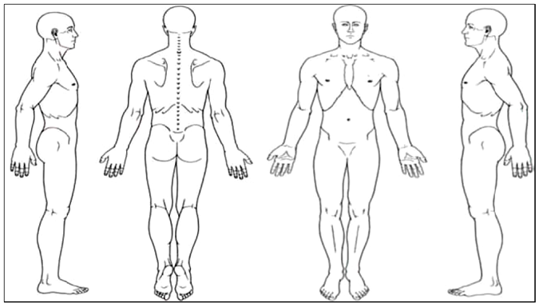

Patient Signature: ________________________________________________ Date: _____/_____/_____

