NAME: |  | DATE OF BIRTH: |  | AGE:
ADDRESS:
CONTACT DETAILS MOBILE: HOME:
E-MAIL ADDRESS: |  |  | OCCUPATION:  CHILDREN:
WHERE DID YOU HEAR ABOUT THE CLINIC: | GP NAME & CONTACT NO.:
DESCRIBE YOUR CURRENT PROBLEM AND WHEN IT BEGAN:  __________________________________________________  HOW DID YOUR POBLEM BEGIN?  Quality:  Dull / Sharp Stiffness Stabbing  Numbness Throbbing Pulling Sensation  Tingling Burning Aching  Severity / Pain Scale: 0 1 2 3 4 5 6 7 8 9 10  What makes it worse:  What makes it better:  SHOE SIZE: ________________ WEIGHT:_____________________ |  | MARK AN x ON THIS PICTURE WHERE YOU HAVE PAIN OR OTHER SYMPTOMS:  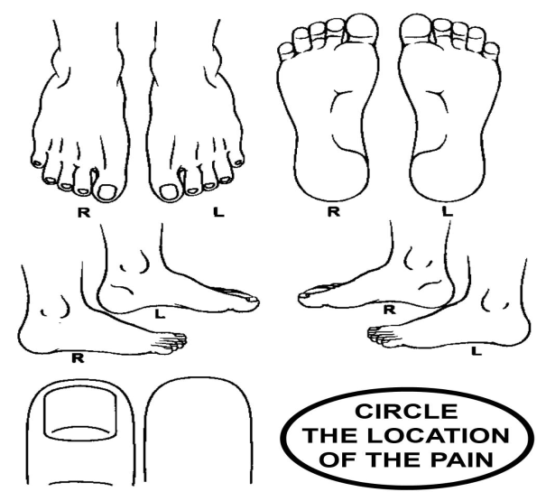
How often are your symptoms present? (Occasional) 0 – 25% 26 – 50% 51 – 75% 76-100% (Constant)

In the past week, how much has your pain interfered with your daily activities (e.g. work, social activities or household chores)?
0 1 2 3 4 5 6 7 8 9 10
No interference Unable to carry on any activities

In general how would you say your overall health is right now:
Excellent Very good Good Fair Poor
Have you had spinal x-rays, MRI, CT Scan for your area(s) of complaint? No Yes
Date(s) taken ____________________________ What areas were taken? ______________________________
Please check all of the following that apply to you:
Alcohol/Drug Dependence Prostate Problems
Recent Fever Menstrual Problems
Diabetes Urinary Problems
High Blood Pressure Currently pregnant, # weeks ______________
Stroke (Date ______________________) Abnormal Weight Gain Loss
Corticosteroid Use (Cortisone, Prednisone etc.) Marked Morning Pain/Stiffness
Taking Birth Control Pills Pain Unrelieved by Position or Rest
Dizziness / Fainting Pain at Night
Numbness in Groin/Buttocks Visual Disturbances
Cancer/Tumor (explain __________________________ Surgeries ___________________________________
Osteoporosis Tobacco use – Type:_________________________
Epilepsy/Seizures Frequency:______ _____day
Other Health Problems (explain ___________________ Medications
Family History: Cancer Diabetes High Blood Pressure
Heart Problems/Stroke Rheumatoid Arthritis

CONSENT

I consent to a physical examination by my Chiropractor, to included (as needed) foot examination and Gaitscan.

Signed: ______________________________
Date: ______________________________
PATIENT or PARENT/ GUARDIAN (if under 18 consent must be given by parent or legal guardian.)

I confirm that I have received a full explanation, of the outcomes of the Chiropractor’s assessment and a diagnosis/rationale for care and proposed treatment plan; in terms that I can understand.

I have had the opportunity to ask questions in respect of my reason for attending a Chiropractor. I understand that it is my right to seek a second opinion, at any time; should I wish.

I have been advised of the care options, both Chiropractic and alternates, available to me and acknowledge that any decision to proceed, is based on a full understanding; of the likely benefits and any reasonably foreseeable risks of care. I understand that the outcomes of care, cannot be guaranteed.

I confirm that the financial implications of the proposed plan of care and any available options have been explained to me.

I hereby give consent to the Chiropractor, to retain my personal information, (under GDPR Guidelines); for the purpose of my healthcare.

I also confirm that, I am content, when the Chiropractor deems it necessary and appropriate, I consent for my Chiropractor to contact my general medical practitioner (GP) and for the Chiropractor, using any appropriate means; to discuss aspects of my health or care with my GP.

I understand that the chiropractic diagnosis and treatment plan proposed, is based on the information that I have given to the Chiropractor.

I understand that it is my right to decline care, or withdraw from care, or any aspects of care, at any time. I also understand that I am free to withdraw my consent, to aspects of care.

I understand that I must be committed to attend sessions, on a consistent basis to receive the greatest benefit from treatment. Although I may stop treatment at any time, I agree to inform the Chiropractor of my decision, so that you are aware of my intentions in good time, before the next appointment.

Based on the above, I freely and voluntarily consent to receiving chiropractic care.

Signed: _____________________________________________________

Print Name: _________________________________________________

Date: _________________________________________________

PATIENT or PARENT/ GUARDIAN (if under 18 consent must be given by parent or legal guardian.)

